To whom it may concern:

My patient, XX is an XX-year-old man with a history of Stage XX (TXX N0 M0) adenocarcinoma of the prostate. His original Gleason score was XX (XX+XX). He completed a course of intensity modulated radiation therapy on XX. He was last seen in follow up on XX, after being diagnosed with recurrent metastatic disease in a single lymph node. His most recent PSA is XX ng/mL. An Axumin PET from XX, showed diffuse activity in the lymph node in the XX with intense activity consistent with a metastatic node. His only current site of disease is the pelvic lymph node. I saw him on XX, to discuss radiation treatment using stereotactic body radiation therapy (SBRT) to this solitary lymph node.

There are multiple data supporting the use of ablative doses of radiation to treat metastases. The results from the clinical trial SABR-COMET, which randomized people with oligometastatic disease to standard of care treatment of SBRT. The results demonstrated SABR was associated with an improvement in overall survival, meeting the primary endpoint of this trial, and progression free survival was doubled. In SABR-COMET, 99 patients were randomly assigned at 10 centers internationally. The most common primary tumor types were breast (n = 18), lung (n = 18), colorectal (n = 18), and prostate (n = 16). Median follow-up was 51 months. The 5-year OS rate was 17.7% in arm 1 (95% CI, 6% to 34%) versus 42.3% in arm 2 (95% CI, 28% to 56%; stratified log-rank P = .006). The 5-year PFS rate was not reached in arm 1 (3.2%; 95% CI, 0% to 14% at 4 years with last patient censored) and 17.3% in arm 2 (95% CI, 8% to 30%; P = .001). There were no new grade 2-5 adverse events and no differences in QOL between arms. With extended follow-up, the impact of SABR on OS was larger in magnitude than in the initial analysis and durable over time. There were no new safety signals, and SABR had no detrimental impact on QOL.
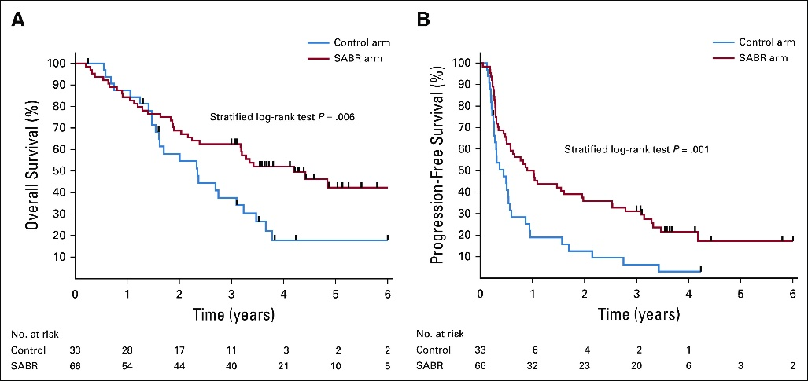

In addition, there are the results of RTOG 0613. This two-arm study compared single 8 Gy palliative radiation with SBRT given at either 16 or 18 Gy for the control of metastatic disease. The use of SBRT was associated with superior local disease and pain control.

Because of the solitary site of oligometastatic disease and the long-term data that demonstrates the efficacy of SBRT, I believe that it is medically necessary for XX to be treated with SBRT.

Please, do not hesitate to contact me with any additional questions regarding this matter.

Respectfully,

Expert Panel on Radiation Oncology-Bone, M., et al., ACR Appropriateness Criteria (R) spinal bone metastases. J Palliat Med, 2013. 16(1): p. 9-19. https://doi.org/10.1089/jpm.2012.0376.
Palma, DS et al. Stereotactic Ablative Radiation Therapy for the Comprehensive Treatment of Oligometastatic Tumors (SABRCOMET): Results of a Randomized Trial. International Journal of Radiation Oncology, Biology and Physics 102: S3-S4; 2018, and the long-term results published in the Journal of Clinical Oncology Palma et al. J Clin Oncol 38:2830-2838; 2020. https://ascopubs.org/doi/10.1200/JCO.20.00818.
Ryu S, et al. RTOG 0631 phase 2/3 study of image guided stereotactic radiosurgery for localized (1-3) spine metastases: phase 2 results. Pract Radiat Oncol. 2014 Mar-Apr;4(2):76-81. doi: 10.1016/j.prro.2013.05.001. Epub 2013 Jun 4. PMID: 24890347; PMCID: PMC3711083. https://www.practicalradonc.org/article/S1879-8500(13)00207-5/fulltext.

